AND

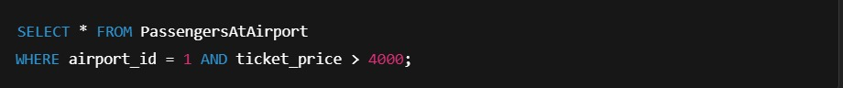



OR

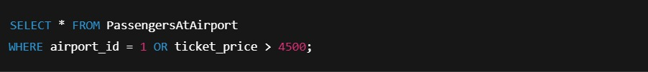

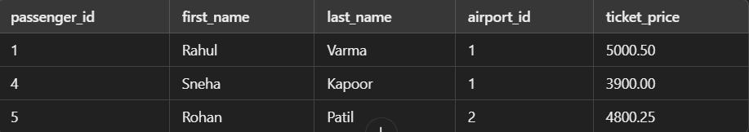

NOT



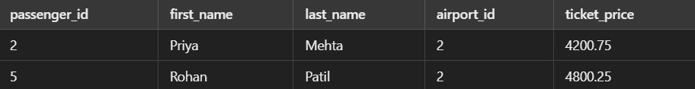

LIKE



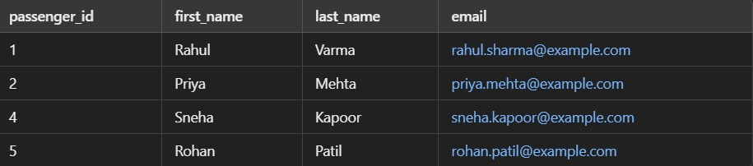

BETWEEN



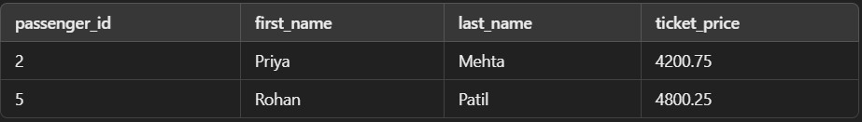

IN

